Experiment 5
Write a program for Implementation of K-Nearest Neighbours (K-NN) in Python
Aim
To implement the K-Nearest Neighbours (K-NN) algorithm in Python to classify data based on the nearest neighbouring data points.
Program
import math
from collections import Counter
# Sample dataset (Height, Weight, Class)
dataset = [
[150, 50, "Underweight"],
[160, 60, "Normal"],
[170, 65, "Normal"],
[180, 80, "Overweight"],
[175, 75, "Overweight"],
[155, 52, "Underweight"]
]
# Function to calculate Euclidean distance
def euclidean_distance(point1, point2):
distance = 0
for i in range(len(point1)):
distance += (point1[i] - point2[i]) ** 2
return math.sqrt(distance)
# KNN function
def knn(dataset, test_point, k):
distances = []
for data in dataset:
features = data[:-1]
label = data[-1]
dist = euclidean_distance(features, test_point)
distances.append((dist, label))
distances.sort(key=lambda x: x[0])
neighbors = distances[:k]
labels = [label for _, label in neighbors]
prediction = Counter(labels).most_common(1)[0][0]
return prediction
# Input test data
height = float(input("Enter height: "))
weight = float(input("Enter weight: "))
test_point = [height, weight]
k = 3
result = knn(dataset, test_point, k)
print("Predicted Category:", result)

Output
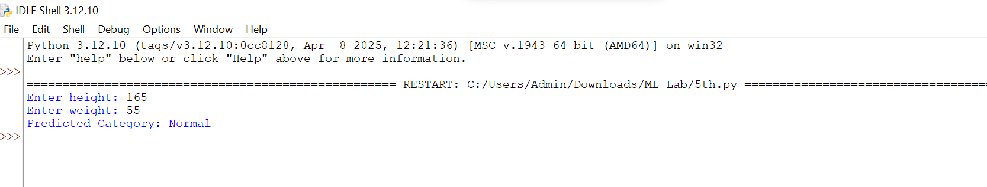

Result
The K-Nearest Neighbours (KNN) algorithm was successfully implemented in Python, and the program correctly predicted the class of the input data based on the nearest neighbours.

